Useful links:

Suspicious -   
<https://dzone.com/articles/a-complete-tutorial-on-the-drools-business-rule-en>

Good - <https://subscription.packtpub.com/book/application_development/9781782165545/1/ch01lvl1sec06/top-5-features-you-need-to-know-about>

Advanced -

<https://docs.jboss.org/drools/release/5.5.0.Final/droolsjbpm-introduction-docs/html_single/>

update($f) - обновляет объект в базе знаний, это форсит перепроверить те правила где этот объект фигурирует, в свое время помогло решить задачу с currency field.

modify($f) { ... } - modifies object, therefore it can be modified directly set..(), get…()

salience <0, negative value> works

import function com.fxclub.fxbank.api.v3.withdraw_api_ws.entity.RequisiteFormCondition.or; - static method.

|  |  |  |  |
| --- | --- | --- | --- |
| REX_EXP_KEY | REX_EXP_VALUE | EXAMPLES | DESCRIPTION |
| VALUABLE_STRING | ^(?!\s*$).+ | Dsfdl;df  fdsd | Any string, but not spaces, \n, \t and so on. |
| PERCENT_VALUE | (^100([\.,]0{1,2})?$)|(^([1-9]([0-9])?|0)([\.,][0-9]{1,2})?$) | 100  0,23  23,34 | Number between 0 and 100 with two digits after comma| dot. |
| ZERO_VALUE | ^0((\.|,)(0)+)?$ | 0,000000  0 | Zero value with any number of digits after comma| dot. |
| POSITIVE_NUMBER_ACCURACY_N | => N = 0 /^\d+?$/,  N > 0 ^\\d+((\\.|,)\\d{1," + N + "})?$ | 0,23232323  12.3232  12  434 | Any Number with any number of digits after comma| dot.  Or without digits and dot|comma. |

=

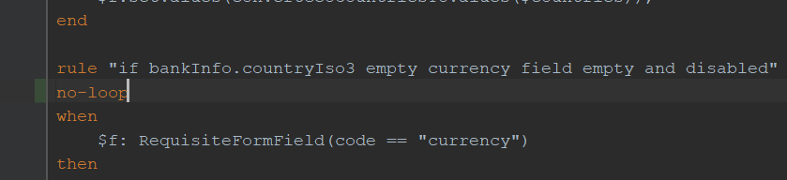  
Ya ETO CHYT NE ZAPYSHIL !!!!  
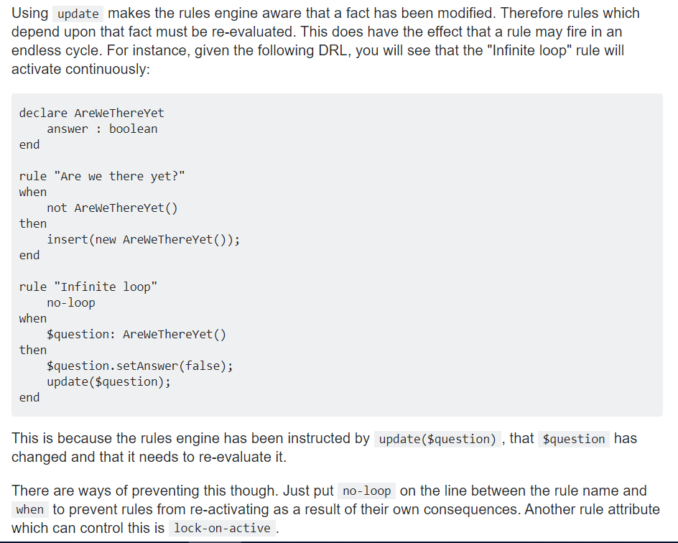

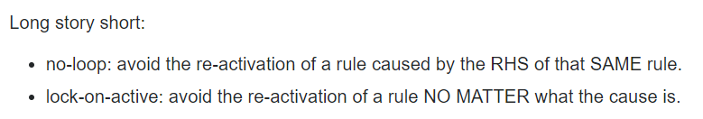

Long story long - <https://ilesteban.wordpress.com/2012/11/16/about-drools-and-infinite-execution-loops/>